CSCE 5430 Software Engineering Project Report (Deliverable - 1)

1. **Project Name:** Student Surplus Website

**Group Name:** DASH

**Group Members:** 1) Sri Sravya Tirupachur Comerica

2) Amisha Gadhia

3) Aboubakar Mountapmbeme

4) Haidi Chen

1. **Project Description:**

The goal of the project is to develop a student surplus website which helps students to buy or sell items that they no longer need such as tables, beds, books and furniture just by posting a picture of the item on-site. It’s like a market place where students have the option to select the product, add them to the cart and checkout. The website also provides an additional security feature which helps students securely exchange the products, the students who are willing sell the items should contact the admin to avoid fraudulent postings on the site. Overall, the website provides students the ease of exchanging the unused items efficiently with added security.

**Technologies:**

* **Web Technologies:** HTML 5, CSS3, JavaScript, JQuery and Bootstrap.
* **IDE:** Eclipse
* **Operating System:** Windows
* **Database:** MySQL
* **Programming Language:** Java
* **Server:** Tomcat 9

**Modules**:

* User module
* Registration module
* Login module
* Admin module
* Category module
* Product posting module
* Search module
* Buying module
* Payment module
* Rating and review module

**Note**: We have scheduled the project timeline based on the dependencies and complexities involved in developing the respective modules.

1. **Project Timeline:**

**PERT Chart:**

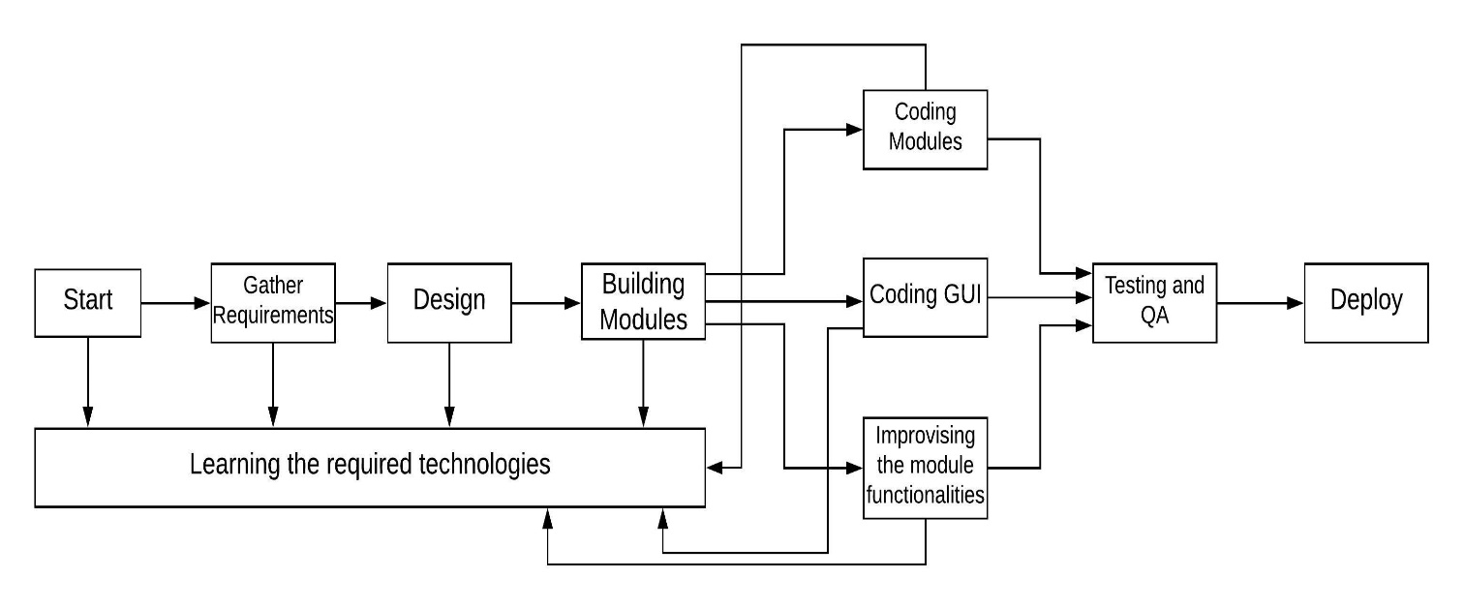

**Milestones:**

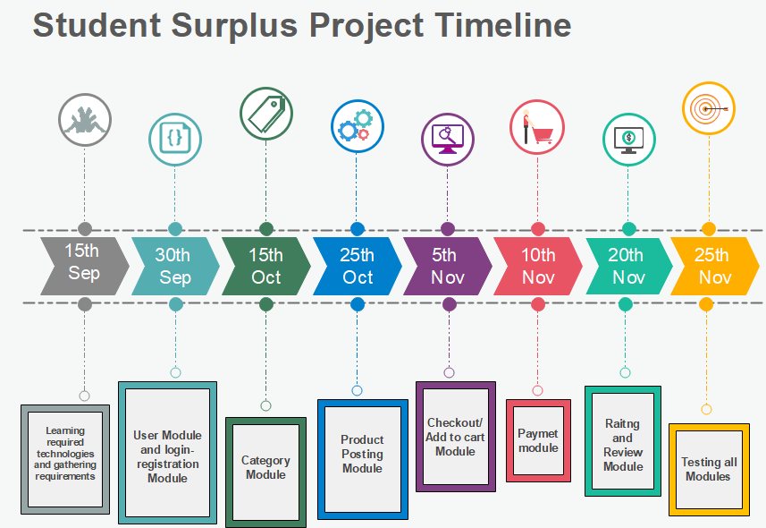

**Activity Diagram:**

The activity diagram below shows the number of days we have assigned to work on each section of our project.

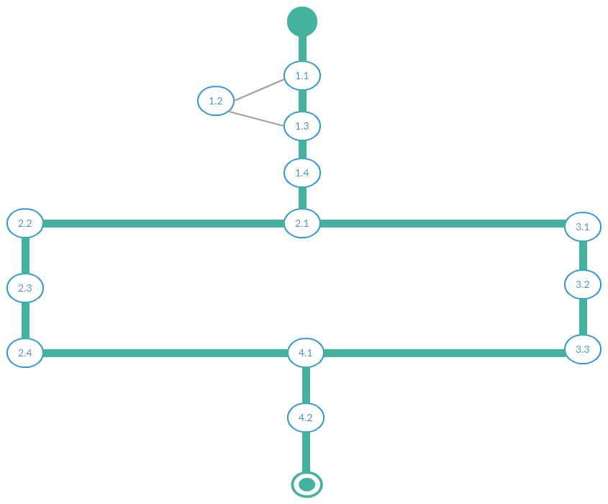

9

3

Gathering requirements

7

Setting up software

6

Design

Building Modules

15

10

100

10

11

25

4

2

1

Coding APIs

Coding GUI

Optimizing and debugging

Coding Business Logic

Back- end layout and DB Setup

Basic GUI Design

Integrating with Front - end

7

Integrating with Back- end

Dividing the roles

Testing

0

Finish

1. **Risk Management**

**Generic Risks:**

1. **Risk: Not adhering to timeline (Schedule):**

**Contingency Plan:** Like in every other project, this is a critical risk to us. As the project development moves forward, we will always check to see whether we are progressing with our established schedule or not and adjust accordingly. In case the risk persists during the project, each team member will give more time to work on the project so that we can meet the timeline.

1. **Risk: Changes in requirements/ new requirements:**

**Contingency Plan:** Because we have not had a detailed analysis of the project before generating the timeline/schedule, we are afraid that unidentified requirements might come up unexpectedly and have negative effects the timeline. In order to mitigate this, we plan to have an in-depth analysis of each module as we progress and if increase requirement threatens the timeline, team members will increase their programming hours to meet the schedule.

**Project Specific Risks:**

1. **Risk: Failure of Payment Method**

**Contingency Plan:** Because payment is one of the critical components of the system, a faulty payment method will have tremendous effects on our system. More attention will be given to the implementation and testing of the payment module. We plan to design an alternative way of payment between the seller and buyer in case the system fails.

1. **Risk: Experience of team members with the technology**

**Contingency Plan:** Initially, we are required to learn about the technologies we will use to build the system. We perceive this as a risk because our rate of learning has an indirect effect on the established timeline. To mitigate this risk, we have already started practicing with the technologies we are going to use in our project. And if any of our team members find it difficult to cop up with a certain technology we plan on training them so that we can efficiently meet the milestones.

1. **Risk: Problem with Integration of modules**

**Contingency Plan:** We believe that it is important to have a proper design to deliver the expected results, while developing different modules we as team members plan on adhering to a certain set of rules so the code can be properly integrated and implemented from time to time. For this, we plan on effectively communicating with each other on a regular basis to review our code and make sure we are all following the exact design that we decided in our design phase.

**Monitoring the risks:** We plan on monitoring the risks, by meeting regularly and discussing about the risks that any team member believes might occur. And take appropriate measures to avoid the risk. Apart from the risks mentioned above we plan on monitoring the risks that might occur during our development phase.

**Re-evaluation of the risks:** As the semester progresses, we plan on strictly following our risk management plan to avoid the occurrence of the risks we’ve mentioned above. We also plan on looking for hints that might lead to new risks and work together in developing contingency plans for those risks.

1. **Team Member Roles:**

* Given that our team members have knowledge in almost all the technologies we plan to use in our projects and given the incremental nature of our development process, we plan to assign roles to each member per module.
* Every team member would be involved in the requirement analysis phase and design phase of all modules where we discuss alternatives and select the best. All team members will work together to design the GUI and database schema as well as the project framework.
* During coding, Team members would be assigned roles based on whether a task is a frontend or backend task. For the first module, Sri Sravya Tirupachur Comerica and Haidi Chen will work on backend tasks and Amisha Gadhia and Aboubakar Mountapmbeme will work on frontend tasks.
* After the first module, we will evaluate our performance and reassign roles if necessary. Depending on the work load involved in a module, a team member may be assigned front end and a backend tasks.

1. **Project repository management Policy**

Each team member would work on his/her own local repository. No one is allowed to work on the master branch.

* We have set up a Whatsapp group so that we can rapidly receive notifications from team members.
* Every team member is required to create a backup of the file that they’re willing to modify. So that we can revert the changes as needed.
* To avoid merge conflicts, no two members should work on the same module at the same time, an intimation regarding which file we plan on working with prior to starting the work is expected.
* Before committing to the master, a team member should send a commit notification to the Whatsapp group that he/she would commit to the master branch within the next 1 hour.